Lab Report for Module 2 Dropbox

Lab: What’s in a Packet Anyways?

Submitted by: Tristan Izlar

1. Step 3, getting the capture option set and ready to start:

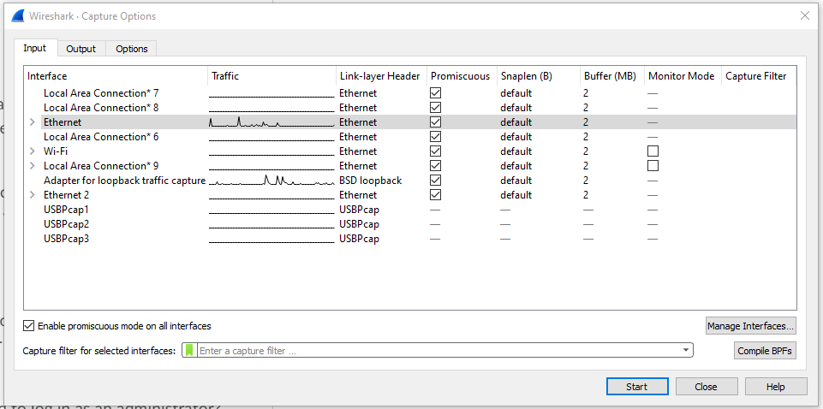

1. Step 4, showing the capture report:

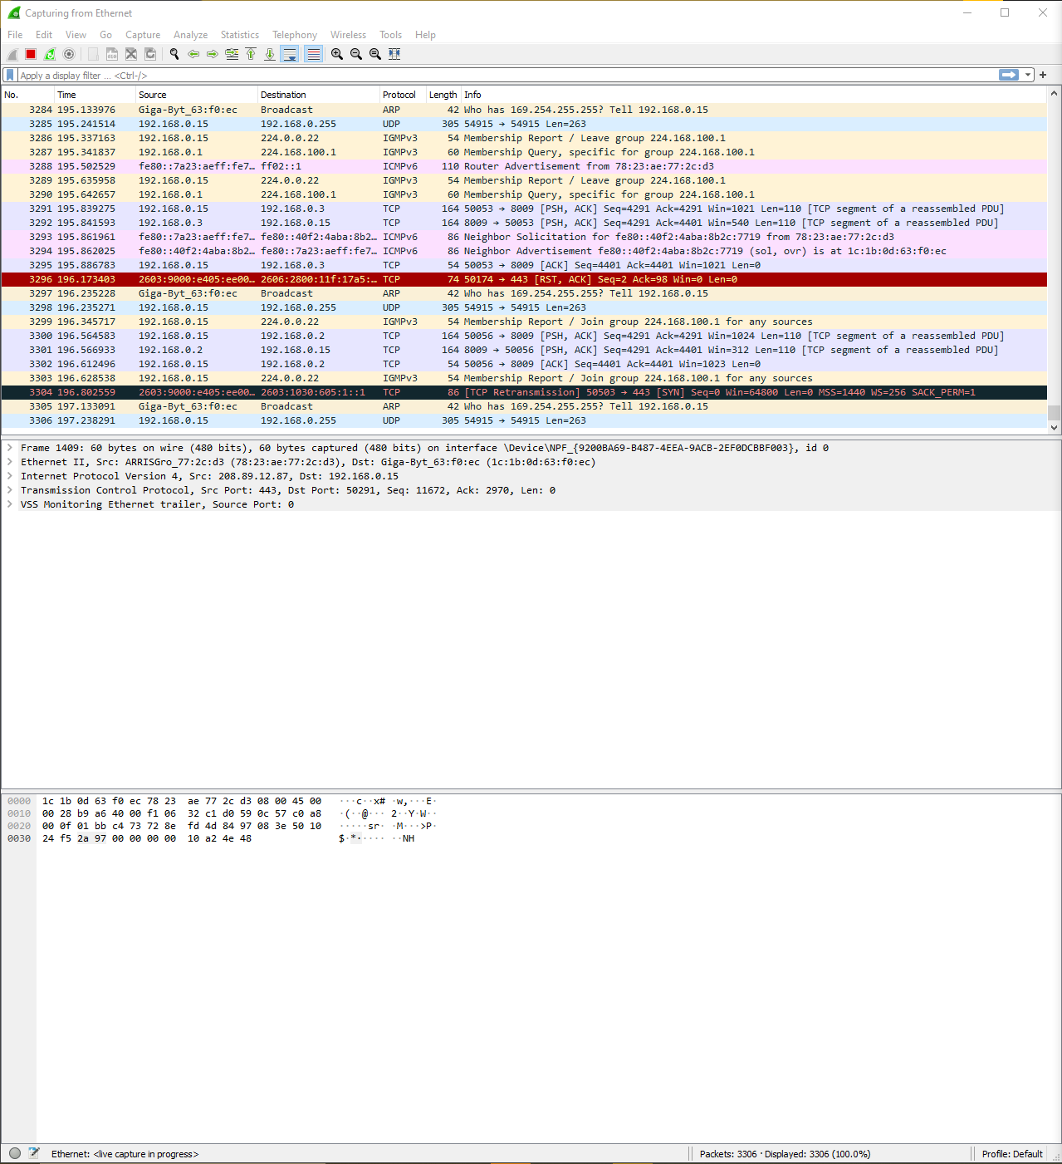

The “Packet List” pane shows all the packets in the capture. The second pane is the “Packet Details” pane, this shows you all the available information on any packet that is selected. The last pane is the “Packet Bytes”, which shows you the packets as they were received (in hexadecimal).

1. Step 5, label the screen shot of the Wireshark window:

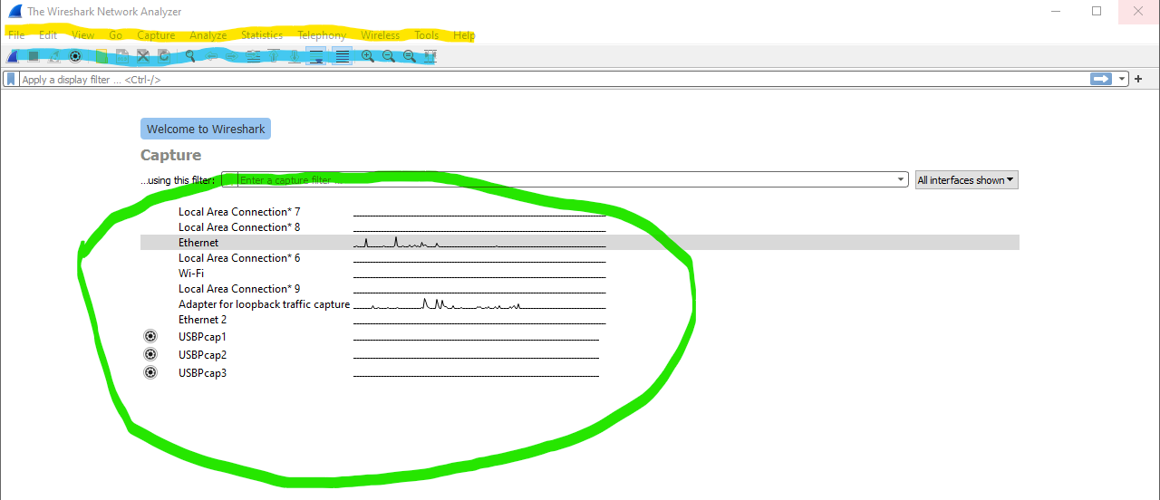

Yellow = menu items

Blue = Buttons

Green = Available interfaces